Design Specification Document

# 1. Introduction

This document describes the Object-Oriented Analysis and Design (OOAD) for the Online Bookstore Application. It includes the Class Diagram, Use Case Diagram, and DynamoDB Data Model to illustrate the structure and interactions of the system components.

# 2. Class Diagram

The Class Diagram shows the main entities (Book, User, Cart, Order) and their relationships. It represents the object-oriented structure of the Online Bookstore Application.

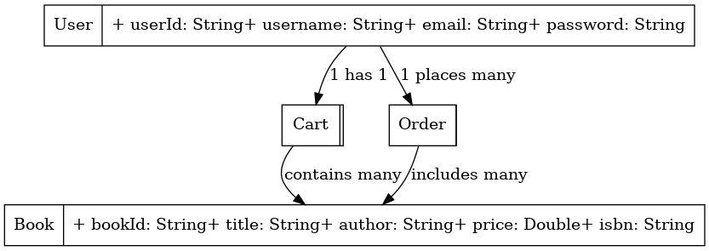

# 3. Use Case Diagram

The Use Case Diagram illustrates how the user interacts with the system. The user can search books, view book details, add or remove books from the cart, proceed to checkout, and view orders.

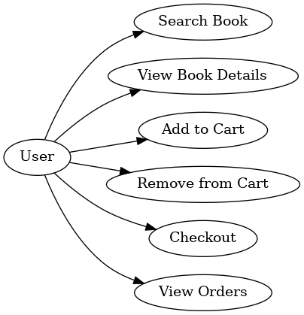

# 4. DynamoDB Data Model

Since the application uses DynamoDB, the data model is based on partition keys, sort keys, and attributes. This diagram represents the structure of the Users, Books, Cart, and Orders tables, along with their relationships.

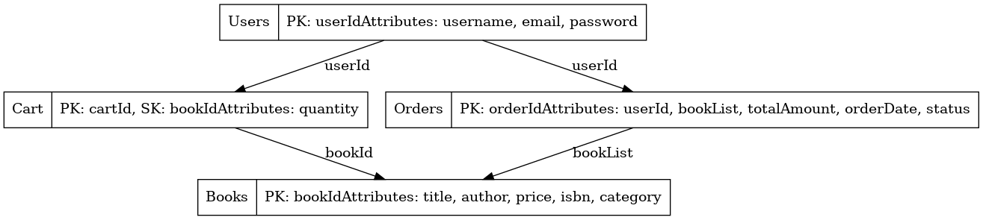

# 5. Deliverables

The following design diagrams have been created and included in this document:  
- Class Diagram  
- Use Case Diagram  
- DynamoDB Data Model  
  
These diagrams will guide the implementation in subsequent phases.